DevOps

Database Migration Service (DMS) 2

# Database Migration Service (DMS)

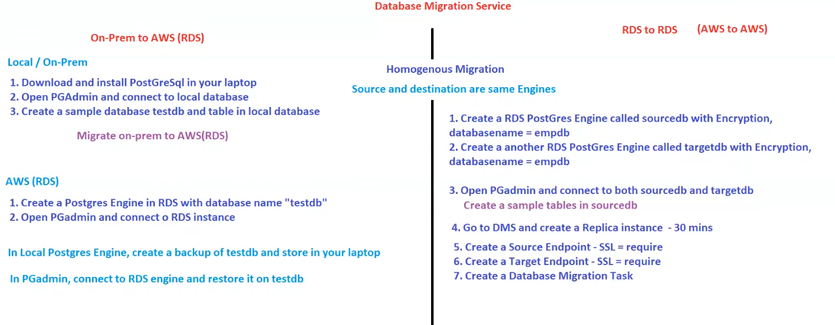

**AWS Database Migration Service (DMS)**

This guide covers two types of **database migrations** using AWS DMS:

1. **On-Prem to AWS (RDS)**
2. **RDS to RDS (AWS to AWS)**

**1. On-Prem to AWS (RDS)**

This method involves migrating a local **PostgreSQL database** to **Amazon RDS**.

**Local / On-Prem Steps**

1. **Download and install PostgreSQL** on your laptop.
2. **Open PGAdmin** and connect to the local PostgreSQL database.
3. **Create a sample database** (testdb) and a table in the local database.

**Migration to AWS RDS**

1. **Create an RDS PostgreSQL instance** with the database name **"testdb"**.
2. **Connect to the RDS instance using PGAdmin**.
3. **Backup the local PostgreSQL database (testdb)** and store it on your laptop.
4. **Restore the backup** to the **RDS instance (testdb)** using PGAdmin.

**2. RDS to RDS (AWS to AWS)**

This method covers **homogeneous migration** (same database engine for source and destination).

**Homogeneous Migration (PostgreSQL to PostgreSQL)**

1. **Create an RDS PostgreSQL instance (sourcedb)**:
   * Enable **encryption**.
   * Use **database name: empdb**.
2. **Create another RDS PostgreSQL instance (targetdb)**:
   * Enable **encryption**.
   * Use **database name: empdb**.
3. **Open PGAdmin** and connect to both sourcedb and targetdb.
4. **Create a sample table** in sourcedb.

**Using AWS DMS for Migration**

1. **Go to AWS DMS** and **create a Replica instance** (takes ~30 minutes).
2. **Create a Source Endpoint** (Enable **SSL**).
3. **Create a Target Endpoint** (Enable **SSL**).
4. **Create a Database Migration Task** in AWS DMS.

**Key Takeaways**

✅ **On-Prem to AWS RDS** is done via **PGAdmin backup and restore**.  
✅ **RDS to RDS Migration** is **automated via AWS DMS**.  
✅ **Encryption & SSL** should be enabled for security in RDS migration.  
✅ **DMS Replication Instance** is required for RDS-to-RDS migration.

**Conclusion**

AWS DMS simplifies **database migration** while ensuring **minimal downtime**. It supports **both on-prem to RDS and RDS-to-RDS migration**.